ICD-102: Bus to Command Interface

1. Document Control

Document Number: SDSU-SB+-ICD-102

Revision: v1.0

Date: March 2026

SDSU Payload Team

2. Purpose
The purpose behind this Interface Control Document is to describe the command path between the OBC to scientific payload of the SentinelBio+ cube satellites. This document will look to describe the command word structure, mode control, sensor enable/disable functions, payload reset, and command acknowledgment behavior throughout all relevant points of communication between these two interfaces.

3. Scope
This document is intended to cover the communication structure between the science payload designed by San Diego State University and the On Board Computer (OBC) designed by San Jose State University. The main channel of communication involves the connection between the Payloads ZES ZSOM-M01 and the Portenta X8 controller

4. Communication Interface Block Diagram

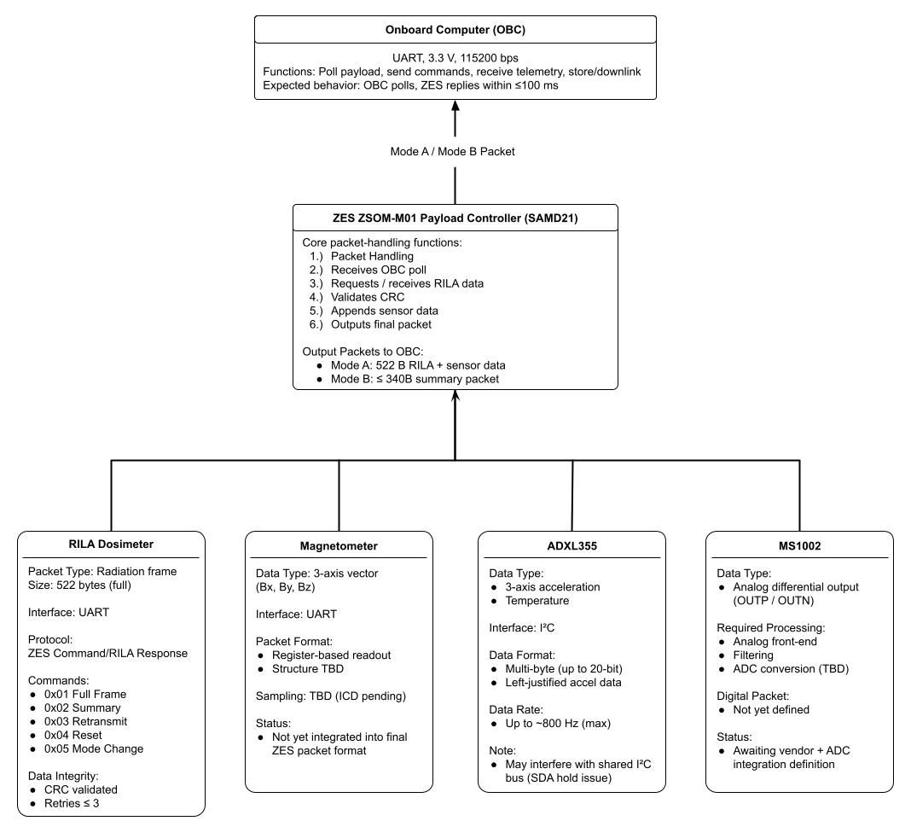

The primary communication interface between the OBC and payload is a 3.3 V UART link, supporting bidirectional command and telemetry exchange. Commands are issued by the OBC, and the payload returns formatted science and housekeeping data.

5. Interface Requirements

5.1 Electrical Interface
The communication interface between the OBC (Portenta X8) and the payload (ZES ZSOM-M01) shall utilize a 3.3 V UART interface. All signal levels, grounding schemes, and electrical characteristics must ensure compatibility and prevent damage to either subsystem.
Logic Level: UART communication shall operate at 3.3 V logic (±5%).
Voltage Limits: Input signals to the ZES shall not exceed 3.6 V.
Output signals shall remain within valid CMOS logic thresholds.
Ground Reference: A common ground shall be maintained between the OBC and payload systems to ensure signal integrity.
Signal Integrity: UART lines shall be routed to minimize noise and interference. Shielding and proper cable management should be applied as necessary.

5.2 Communication Protocol
Communication between the OBC and payload shall be conducted using a UART-based serial protocol.
- Baud Rate: Default communication rate shall be 115,200 bps.
- Data Format: Communication shall follow 8 data bits, no parity, 1 stop bit (8-N-1).
- Architecture: The system shall operate in a master–slave configuration, where:
- The OBC acts as the master, issuing commands
- The payload (ZES) acts as the slave, responding with telemetry

5.3 Command Interface
The OBC shall transmit command packets to the payload to control operation modes, request data, and manage subsystem behavior.
Each command shall consist of an opcode and optional parameters.

Opcode | Command Name | Description
0x01 | Request Full Data | Requests complete payload data packet (Mode A)
0x02 | Request Summary Data | Requests reduced telemetry packet (Mode B)
0x03 | Reset Payload | Resets payload controller (ZES)
0x04 | Enable Sensors | Activates onboard sensors
0x05 | Mode Change | Switches between operational modes

- Commands shall be transmitted via UART from the OBC.
- The payload shall acknowledge valid commands through a response or telemetry packet.
- Invalid or unrecognized commands shall be ignored or flagged.

5.4 Telemetry Interface
The payload shall transmit telemetry data to the OBC in response to command requests. Telemetry includes science data and housekeeping information.
Each telemetry packet shall follow a structured format to ensure consistent parsing.
Field | Size | Description
Header | 1 byte | Packet start identifier
Timestamp | 4 bytes | Time of data acquisition
Payload Data | Variable | Sensor and radiation data
Status Flags | 1 byte | System health indicators
CRC | 2 bytes | Error detection
- Packet structure shall remain consistent across all modes. The Main payload data will fluctuate depending on the Mode as listed in section 5.5
- CRC shall be used to validate data integrity.
- Packet Loss shall be minimized using the ZSOM-M01s onboard ZES EDAC code which Recovers Corrupted Data. In the event of this system failing or dropped frames on board software will flag and alert the OBC.

5.5 Data Modes
The payload shall support multiple telemetry modes to optimize data transmission and bandwidth usage.
Mode | Description | Approx. Size
Mode A | Full Data Mode (complete dataset including radiation spectra and sensor data) | ~522 bytes
Mode B | Summary Mode (condensed dataset including key measurements and housekeeping data) | ≤340 bytes
- The active mode shall be selectable via command from the OBC.
- Mode selection shall persist until changed by command or reset.

5.6 Timing and Performance
The communication interface shall meet the following timing and performance requirements:
- Response Time: The payload shall respond to OBC commands within ≤100 ms.
- Command Frequency: The OBC shall issue commands at a rate consistent with mission operations (e.g., periodic polling every 15 minutes).
- Data Throughput: The UART interface shall support transmission of full data packets without overflow or data loss at the specified baud rate.
- Latency: End-to-end latency from command issuance to telemetry receipt shall remain within acceptable mission limits.

6. Operational Concept/Modes

This section describes the system-level functional behavior of the payload during different phases of operation and defines how the OBC interacts with the payload through command and telemetry exchange.
6.1 System Initialization

6.2 Standby Mode

6.3 Active Mode

6.4 Data Acquisition Cycle

9. Verification

9.1 Tests

Test Description | Method
Verify UART communication link | Establish serial connection between OBC and payload; confirm bidirectional communication
Verify command transmission | Send defined command opcodes from OBC and monitor payload response
Verify telemetry packet structure | Capture payload output and confirm correct packet format and field structure
Verify data mode operation | Issue mode change commands and confirm correct packet size and content (Mode A / Mode B)
Verify CRC / error detection | Inject corrupted data or simulate transmission errors and confirm detection behavior
Verify response timing | Measure time between command transmission and payload response
Verify invalid command handling | Send undefined or malformed commands and observe system response

9.2 Acceptance Criteria

The communication interface shall be considered verified if all tests meet the following criteria:

UART Communication: Stable bidirectional communication is established with no data loss at the specified baud rate (115,200 bps).

Command Execution: All valid commands are correctly received and executed by the payload.

Telemetry Integrity: Telemetry packets conform to the defined structure and contain valid data fields.

Data Modes: Mode A and Mode B outputs match expected packet sizes and content definitions.

Error Handling: CRC or transmission errors are detected and handled according to defined behavior.

Timing Performance: Payload response time shall not exceed 100 ms from command receipt.

Invalid Commands: Invalid or unrecognized commands do not cause system failure and are safely ignored or flagged.

